**How to compare Images in Selenium using AShot API || Working with AShot API**

<https://www.youtube.com/watch?v=1CBS1AQy6zo>

We need to download below APIs for

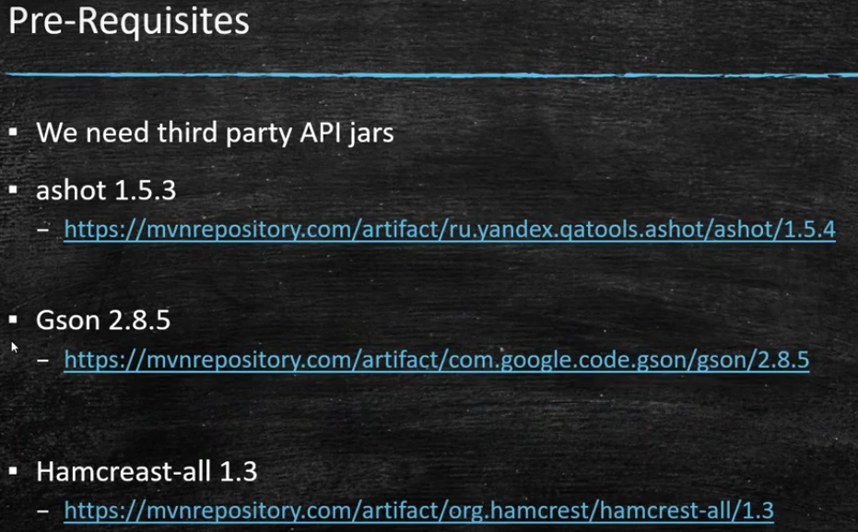

You have to download the first link below

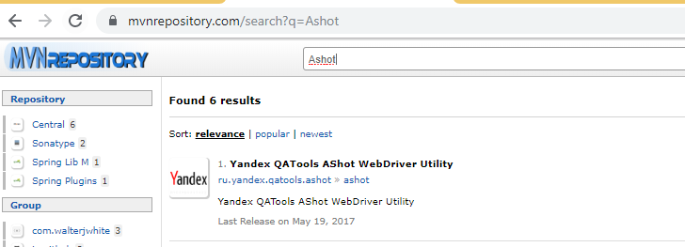

If ur using normal Java project, download the jar file below or if any maven project dependency from below

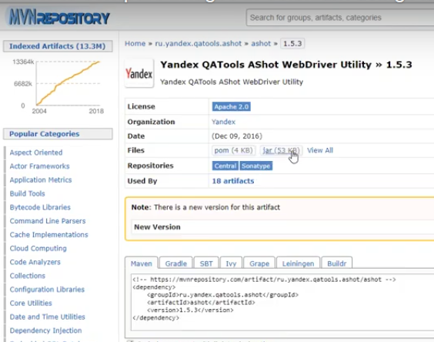

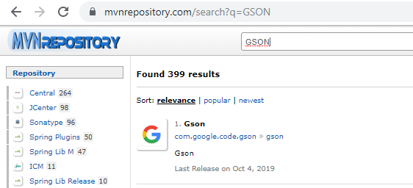

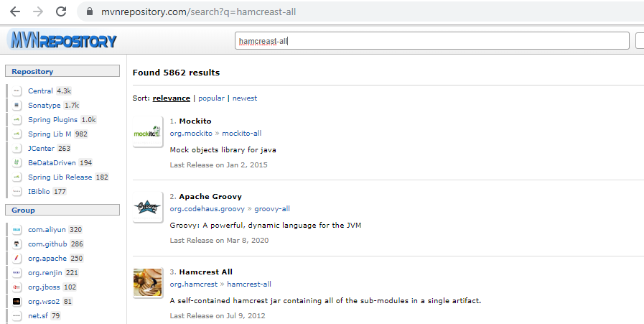

Here need to capture the Logo from below

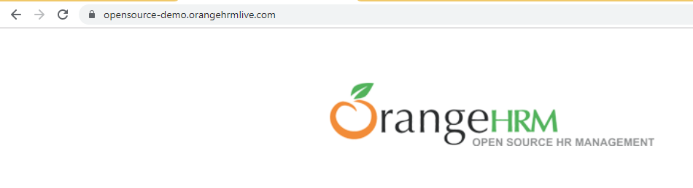

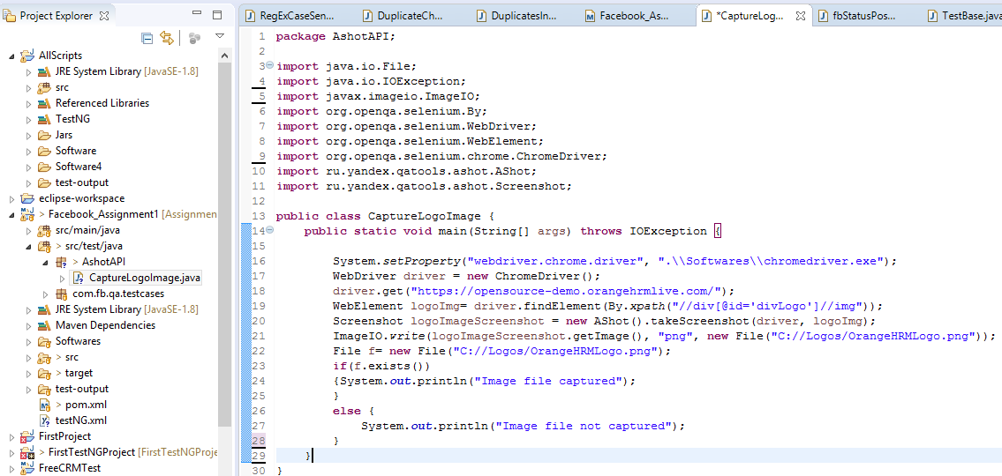

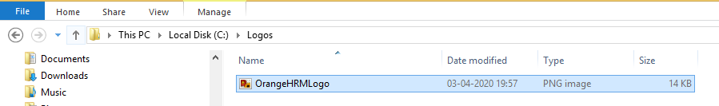

COMPARE ACTUAL AND EXPECTED IMAGES

